Problem Set # 2

Marjorie Blanco

February 8, 2018

# Life Expectancy in the Americas

ggplot(data = gapminder %>% filter(continent == "Americas"),  
 aes(x = year, y= lifeExp, group = country)) +  
 geom_point(color = "dodgerblue") +  
 geom_line() +  
 facet_wrap( ~ country) +  
 theme_bw() +  
 theme(axis.text.x = element_text(angle = 90, vjust = 0.5, size = 8)) +  
 xlab("Year") +  
 ylab("Life expectancy") +  
 ggtitle("Life Expectancy in the Americas")

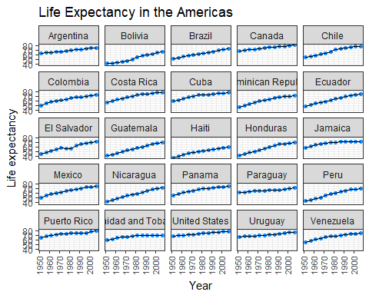

# Central America GDP per capita

countries <- c("Belize", "Costa Rica","El Salvador", "Guatemala", "Honduras", "Nicaragua", "Panama")  
ggplot(data = gapminder%>% filter(country %in% countries),  
 aes(x = year, y = gdpPercap, group = country)) +  
 geom_line(alpha = 0.5) +  
 facet_wrap( ~ country) +  
 xlab("Year") +  
 ylab("GDP per capita") +  
 ggtitle("GDP per capita Over Time") +  
 guides(color = FALSE) +  
 theme_bw() +  
 theme(axis.text.x = element_text(angle = 90))

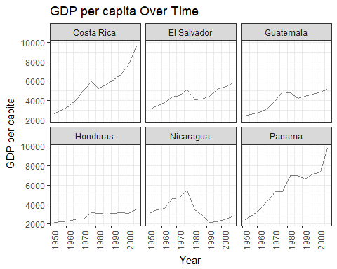

# 

# Life Expectancy in the Africa

ggplot(data = gapminder %>% filter(continent == "Africa"),  
 aes(x = lifeExp)) +  
 geom_histogram(bins = 10, colour="black", fill = "dodgerblue") +   
 facet_wrap( ~ year) +   
 xlab("Years") +  
 ylab("Life Expectancy") +  
 ggtitle("Life Expectancy Over Time in Africa") +  
 theme_bw()

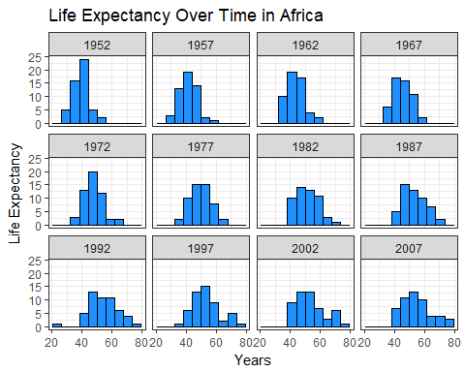

# Life Expectancy in the Central America

ggplot(data = gapminder %>% filter(country %in% countries),  
 aes(x = year, y = lifeExp, group = country)) +  
 xlab("Year") +  
 ylab("Life Expectancy") +  
 geom_line(alpha = 0.75) +  
 facet_wrap( ~ country, nrow = 5) +   
 scale_size_manual(name = "Unit", values = c("Actual" = 1)) +  
 scale_x_log10(breaks = c(1950, 1970, 1990, 2010)) +  
 theme_minimal(base_size = 8) +  
 theme(axis.text.x = element_text(angle = 90)) +  
 theme_light()

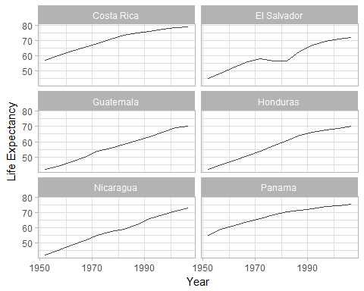

# Life Expectancy Haiti vs. Nicaragua

ggplot(gapminder %>% filter(country %in% c("Haiti", "Nicaragua")),  
 aes(x = year , y = lifeExp)) +  
 geom_line(aes(linetype = country, color = country), show.legend = FALSE) +  
 geom_point(aes(size = country), shape = 21, fill = "white", show.legend = FALSE) +  
 annotate("text", x = c(1975, 1985), y = c(56, 43), size = 6, label = c("Haiti", "Nicaragua")) +  
 scale_size_manual(values = c(3, 3)) +  
 labs(x = "Year", y = "Life Expectancy") +  
 ggtitle("Life Expectancy in Haiti vs. Nicaragua") +  
 theme(panel.grid.major = element_blank(),  
 panel.grid.minor = element_blank(),  
 plot.title = element_text(size = rel(1.2),  
 face = "bold",  
 vjust = 1.5))

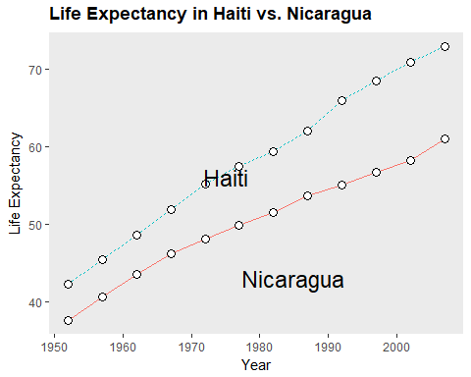

# GPD per capita in the Central America

ggplot(data = gapminder %>% filter(country %in% countries),  
 aes(x = country, y = gdpPercap)) +  
 geom_boxplot(outlier.shape = 5) +   
 coord_flip() +  
 labs(y = "GPD per capita") +  
 ggtitle("Box Plot Summary of GPD per capita in Central America from 1952-2007") +  
 theme_classic() +  
 theme(panel.grid.major = element_blank(),  
 panel.grid.minor = element_blank(),  
 plot.title = element_text(size = rel(1.2), face = "bold", vjust = 1.5),  
 axis.ticks.y = element_blank(),  
 axis.title.y = element_blank())

